612/1
IPS ART & CRAFTS
Paper 1
2023
2 hours

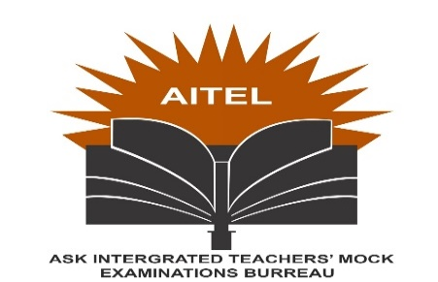

AITEL JOINT MOCK EXAMINATION
Uganda Certificate of Education
IPS ART AND CRAFTS
STUDIO TECHNOLOGY
PAPER 1
2 hours

INSTRUCTIONS TO CANDIDATES:
Answer all the questions
Drawing and diagrams should be used where necessary.

- Define the term perspective. (2mks)
b. Describe the two types of perspective. (2mks)
2. Define the term craftsmanship. (2mks)
b. Mention five roles of a Marquette to a sculptor. (5mks)
3. Define the term mask. (2mks)
b. Mention two roles of polythane paper during the execution of a paper machie mask. (2mks)
4. State the major use of wax during batik making. (1mk)
b. Mention two tools used in batik making. (2mks)
5. Define the term serigraphy. (2mks)
b. In which ways is a motif important to a fabric designer. (5mks)
6. Define the term a beam house in relation to leather processing (2mks)
b. Mention the three general raw materials for leather processing. (3mks)
7. Define the term armature as used in sculpture making. (2mks)
b. Briefly describe four elements used in in three dimensional art work. (4mks)
8. Mention four methods of decorating fabrics. (4mks)
b. Why is it important to rinse a piece of fabric in clean water before dyeing it? (1mk)
c. Describe the process of coming up with a stitched tie and dye fabric. (6mks)
9. Mention four types of glazes. (2mks)
b. Give two reasons why glazing a ceramic piece is good? (1mk)
10. Mention three methods of making a piece of a design flow. (3mks)

